This is taken from a book on http://books.google.com. It is a copy of a contract indenturing William Hatfield to George Wintermute

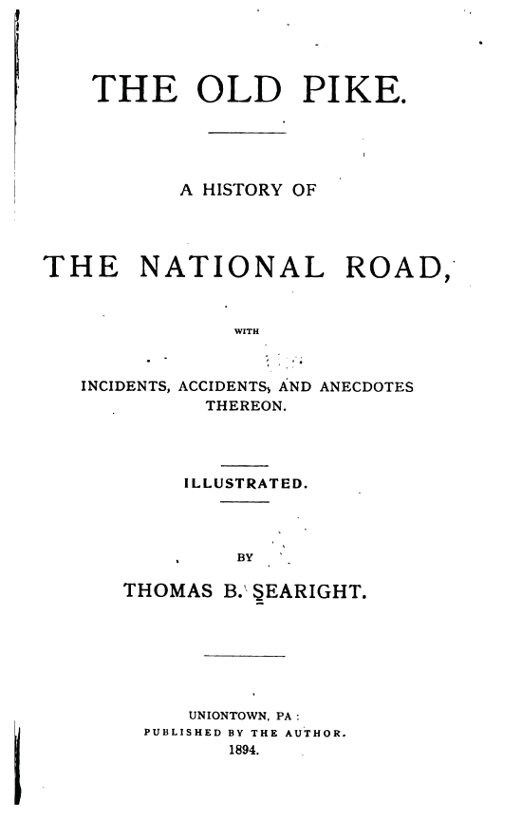

Page 252

